MVP update:

Use this text after asking for requests:

ask me any questions you need clear defined answers to before generating anything. If the answers are not precise enough ask again before generating. We’re striving for quality.

Portfolio page: Edit current portfolio page

Add cash reserve section, with feature to add cash deposit into account.

Step 1: Deposit Initiation
- User clicks "Add Money" from portfolio or any investment screen
- System checks user KYC status and account verification level
- Display current cash balance and recent transaction history
- Show suggested deposit amounts based on user's investment goals
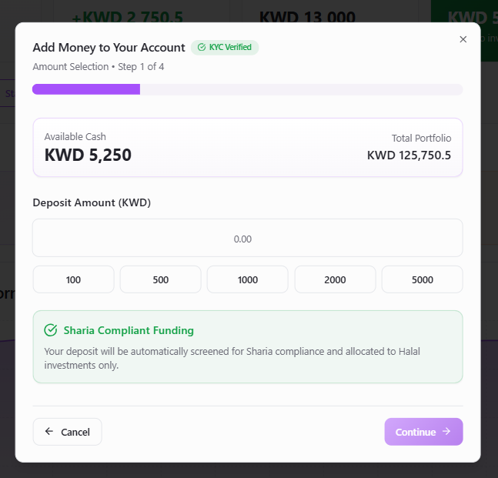

Step 2: Amount Selection & Validation
- Smart amount input with quick-select options (100, 500, 1000, 2000 KWD)
- Real-time validation against daily/monthly limits
- Display fee structure and net amount to be credited
- Show projected settlement times for each method
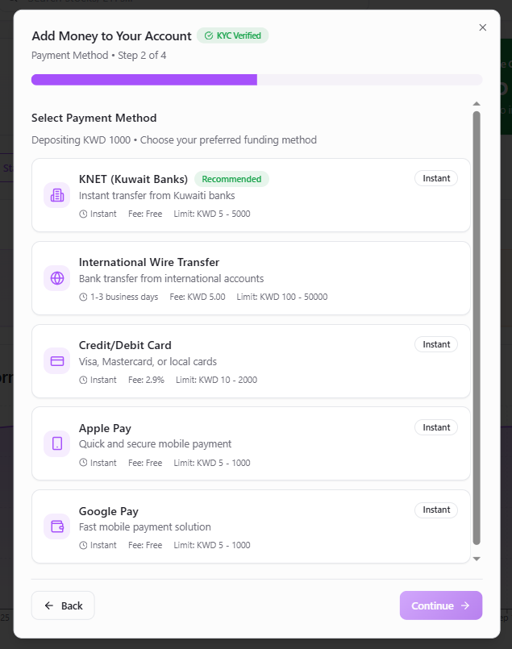

Step 3: Enhanced Payment Method Selection
- Bank Transfer (KNET/Local): Instant for Kuwaiti banks, 1-2 hours processing
- International Wire: 1-3 business days, with SWIFT tracking
- Digital Wallet: Apple Pay, Google Pay, Samsung Pay - instant
- Credit/Debit Card: Instant but with processing fees (2.9%)
- Cryptocurrency: USDC/USDT conversion (if regulatory approved)

Step 4: Security & Verification
- Two-factor authentication for amounts over 1000 KWD
- Biometric confirmation (if available)
- Risk assessment based on deposit patterns
- Anti-money laundering checks

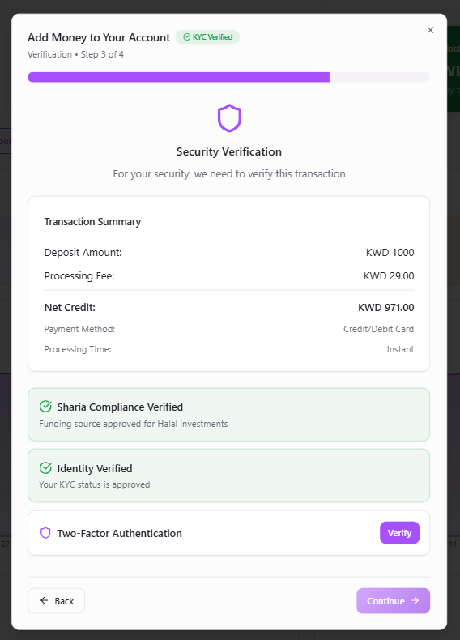

Step 5: Confirmation & Tracking
- Detailed transaction summary with reference number
- Estimated credit time with notification preferences
- Integration with investment queue (auto-invest existing pies)
- Receipt generation with audit trail

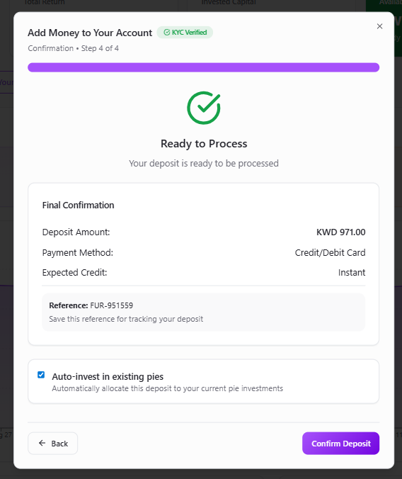

Multi-Step Investment Flow Architecture
Transform the current PortfolioBuilderModal into a comprehensive 6-step wizard:
Clicking each pie should drop down with pie breakdown

Step 1: Select Pie (Enhanced current functionality)
- Keep existing tabs: Custom Pie | Model Pies | Community Pies
- Add breadcrumb navigation : "Select Pie → Investment Method → Configure → Name Pie → Confirm"
- Store selected pie data for subsequent steps
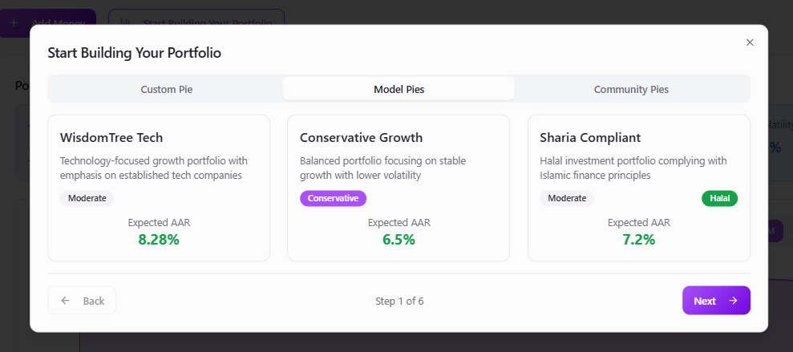

Step 2: Investment Method
- Two card-based options: "Manual Investment" vs "AutoInvest"
- Manual: One-time investment from available cash
- AutoInvest: Recurring investment with projections
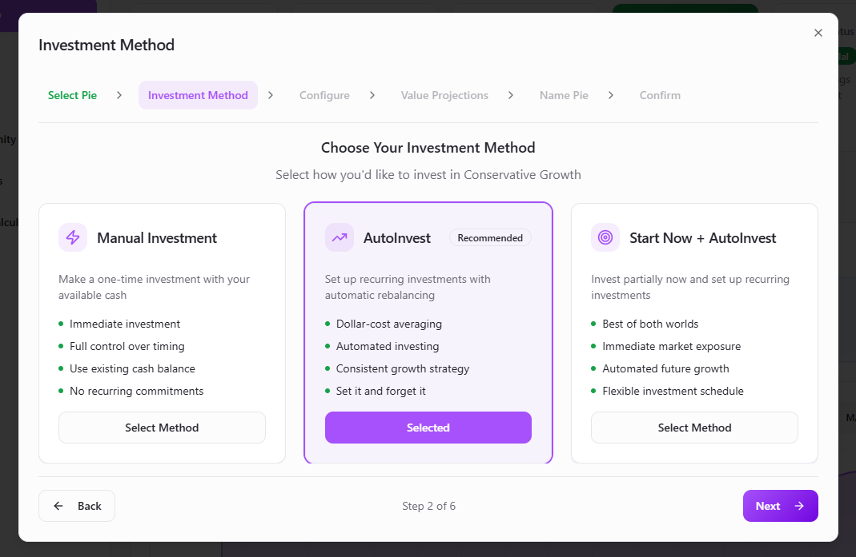

Step 3: Configure Investment
- Manual Path: Simple amount input (min KWD 5, max KWD 50,000)
- AutoInvest Path: Advanced configuration with 3 sliders:
  - Initial Deposit: KWD 5 - KWD 50,000
  - Monthly Contribution: KWD 0 - KWD 2,000
  - Investment Day:
  - Investment Duration: 1-30 years
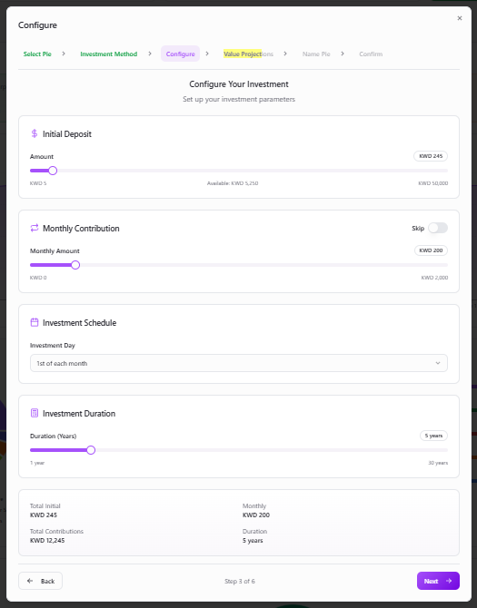

Step 4: Value Projections (AutoInvest only)
- Multi-scenario toggle: Conservative/Expected/Optimistic with Expected as default
- Return calculations:
  - Conservative: Selected pie AAR - 2%
  - Expected: Selected pie AAR
  - Optimistic: Selected pie AAR + 2%
- Visual chart: Replicate uploaded reference image - grey bars (contributions) vs blue area (projected value)
- Real-time updates: Chart recalculates as sliders change
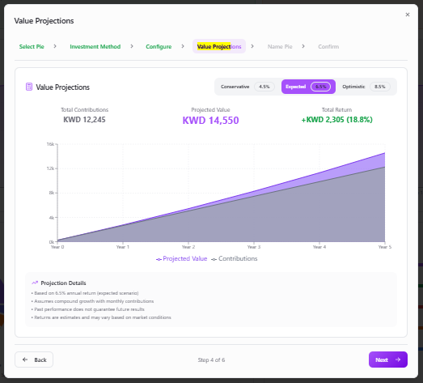

Step 5: Name Pie & Goals
- Required custom name: Text input for pie personalization
- Preset goal templates: "Retirement "House Down Payment "Emergency Fund ", "Vacation Fund - labels only
- The Years should be already set from configure section
- Optional description: Text area for investment notes
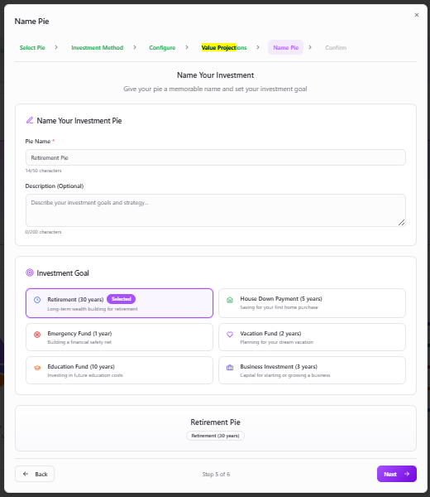

Step 6: Finalize & Confirm
- Complete investment summary: All details, amounts, projections
- Terms checkbox: Required acceptance
- Final confirmation: "Confirm Investment" button
- Success redirect: Back to Portfolio page with new pie in "My Pies"
